Paper Title of Your Manuscript for 10th ISFEH

Surname A.1, Surname B.1,*, Surname C.2

1 Institution/Organization, Department, City, State/Province, Country.

2 Institution/Organization, Department, City, State/Province, Country.   
*Corresponding author’s email: [scientist@institution.com](mailto:scientist@institution.com)

# ABSTRACT

For MS Word users, the best way to achieve compliance with the requested format is by using this file as a starting point and pasting material in as “text only”. The following instructions are for users that may choose a different approach. The paper title uses font of 13 pt Arial Bold, and has all the notional words capitalized. The abstract retains the formatting of this paragraph. It should include a concise (200-300 words) description of the results and findings of the research. It should not contain any equation. Any reference cited in the abstract must be given in full. Use 9 pt Times New Roman single spaced, making an indentation of 7 mm on the right margin. Also, non-standard or uncommon abbreviations should be avoided, but if essential they must be defined at their first mention in the abstract itself. Include 3-4 keywords (avoid, for example, “and”, “of”) for indexing (in alphabetical order). For the keywords, only abbreviations firmly established in the field may be eligible.

**Keywords:** Keyword1, keyword2, keyword3, keyword4.

# Nomenclature

[This paragraph should be deleted in the final manuscript. If symbols are used extensively, a nomenclature listing, arranged alphabetically in a two-column format, must be included immediately following the Keywords. Otherwise all symbols should be identified when first used in the text. It is recommended to use Mathtype software or Microsoft Equation 3.0 for editing the nomenclature listing, for which the size of all symbols must be 10 pt. All *subscript* and *superscript* symbols appear separately. If units are provided, include them in parentheses. Use the international system (SI) of units. The example below, if used as a template, will satisfy the format requirements outlined above.]

 constant pressure specific heat (J/(kg·K))

 heat transfer coefficient (W/(m2·K))

 absorbed radiant flux (W/m2)

 sample thickness (m)

 heat flux (W/m2)

 heat release rate (W/m3)

 path length (m)

 temperature (K)

 time (s)

 mole fraction (-)

 mass fraction (-)

**Greek**

 emissivity (-)

 viscosity (m2/s)

**Subscripts**

 ambient

**Superscripts**

 fire

# MAIN HEADING

Insert the body of your document here, retaining the formatting of this paragraph. All ISFEH paper submissions must follow this Word template. Page size is B5(ISO) (17.6 × 25 cm), with 2 cm top and bottom, and 1.7 cm side margins. The font is Times New Roman single spaced, with font sizes as follows: authors 11, addresses 10; body 10; and captions and footers 10. Do not change the paragraph attributes, paper size, margins, headers, or footers. Recommended size of your paper **should not exceed 10 pages**. Papers exceeding 12 pages will be returned to the authors for reduction. Use a 6 pt space after each period.

Organize the manuscript as follows: Abstract, Keywords, Nomenclature (if used), Introduction, Main Body, Conclusions, Acknowledgments, References, and Appendices (if included). DO NOT use numerals to denote separate sections and subsections of the Introduction, Main Body, and Conclusions.

Indicate references in the text using full-size consecutive numbers in brackets, i.e., [1]. Include the full title in the references list (see below). The Reference style format uses indented paragraphs and applies consecutive numbers.

Additional formatting instructions are provided below in “Other Document Components”.

Final submission (after review and paper revision) must be both in MS Word and pdf formats, with the maximum file size of 3 MB. While using MS Word you may find it best to modify the docx version of this template file into your paper. Your filename should include the first author’s surname and an abbreviated title. For this example, a good filenames would be *Surname-Template.doc(x)* and *Surname-Template.pdf*. Please choose to embed all fonts when generating pdf file. Before uploading your pdf, please view it on different computers to verify proper appearance of all fonts and graphics.

Initial paper submission requires pdf files only.

# MAIN HEADING

Continue body text here.

## Supplementary Heading

Continue body text here.

# Other DOcument Components

## Abbreviations and acronyms

Write out abbreviations or acronyms at their first mention in the text, followed by the abbreviation or acronym in parenthesis.

## Equations

For keeping consistent format, Equations should be edited by Mathtype software or Microsoft Equation 3.0. Please do not use the default equation editor of Microsoft Word. For equations, **the size of all symbols MUST be set to 10 pt.** Number your equations consecutively in the text and refer to them as Eq. (1), etc. However, if “Equation” is the first word in a sentence, spell it out. In principle, variables are to be presented in italics. Powers of e are often more conveniently denoted by exp. An equation style has been provided, which includes a right aligned tab for the equation number and extra space after it. For example,

, (1)

where ** is mass (kg), ** is radius (m), and ** is temperature (K). Authors are also encouraged to use Mathtype software or Microsoft Equation 3.0 to edit the symbols of the equation in the text.

Present simple formulae in line with normal text where possible and use the solidus (/) instead of a horizontal line for small fractional terms, e.g., .

## Figures

**Color of figures:** An online version of the ISFEH proceedings will be available, for which the figures can be in color. However for the printed version, the ISFEH proceedings will be in grayscale (not color), so ensure that your figures are meaningful without color printing. In practice, this means not using color alone as a way of distinguishing different data sets. Line type and symbols will serve the purpose.

**Resolution of figures:** ensure that all figures have high resolution, and do not use figures that are disproportionately large for the content. For vector drawings, embed all used fonts. For color or grayscale photographs (halftones), keep to a minimum resolution of 300 dpi. For bitmapped (pure black and white pixels) line drawings, or combinations bitmapped line/half-tone (color or grayscale), keep to a minimum of 600 dpi.

**Numbering of figures:** Number and refer to your figures consecutively, e.g., Fig. 1 and Fig. 2. However, if “Figure” is the first word in the sentence, spell it out. Figure parts should be labeled with lowercase letters, e.g., Fig. 2 a. Figures must be placed in close proximity to the text that references them the first time. Make sure that colored artwork is well represented when printed in black and white.



**Fig. 1.** Figure caption followed by period.

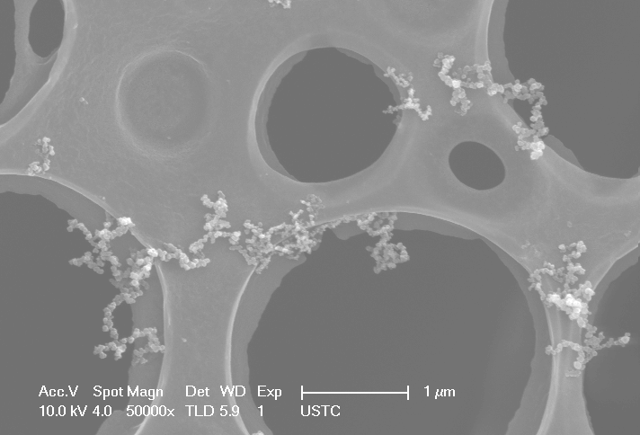 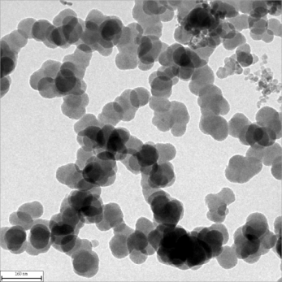

(a) (b)

**Fig. 2.** Characteristics of fire smoke particles. (a) SEM image; (b) TEM image.

**Captions of figures:** Each figure must have a number and a caption, as in the example below. The caption should be as concise as possible – detailed information should be moved into the text. Figure captions should be centered below the figures. **The words of the captions must be 9 pt in size.**

**Format of figures:** Figures should be centered. Make sure you use uniform lettering and sizing of your original figure. Aim to use the following fonts in your figures: Arial, Courier, Times New Roman, Symbol, or use fonts that look similar.

## Tables

**Numbering of tables:** Each table must have a number and a title, as in the example below. Number tables consecutively (e.g., Table 1) in accordance with their order of appearance in the text and place any table notes into an embedded cell below the table body. Table notes should be indicated by superscript letters, beginning with “a”.

**Title of tables:** The title should be as concise as possible – detailed information should be moved into the text. Table titles should be centered above the tables.

**Format of tables:** Insert tables as editable text and not as images. Tables should be centered. All the words and symbols inside a table should be 9 pt in size. If you use Mathtype software or Microsoft Equation 3.0 to edit the equations or symbols inside a table, **set the size of all symbols to be 9 pt.** Tables should be placed next to the relevant text in the article. Do not break the table across successive pages.

Table 1. Table title (with the first word being capitalized) followed by period

|  |  |  |  |
| --- | --- | --- | --- |
| Column 1 | Column 2 | Column 3b | |
| Left align text in table rows  for better legibilitya | 31 | 449.6 |
| Sample text | 30 | 88.8 |
| Sample text | 29 | 516.5 |
| Sample text | 29 | 6.4 |
| aTable footnotes are referenced by superscript letters.  bDecimal alignment of numbers in columns improves legibility. | | | |

Be sparing in the use of tables and ensure that the data presented in them do not duplicate results described elsewhere in the article. Avoid using vertical rules and shading in table cells.

# References

Make sure to strictly abide by the requirements on reference formatting as follows.

Ensure that every reference cited in the text is also present in the reference list (and vice versa). Unpublished results and personal communications are not recommended in the reference list, and if necessary, they can be cited in parenthesis within the text. Citation of a reference as “in press” implies that the item has been accepted for publication. Citing non-archival publications is strongly discouraged and authors must ensure that these references are publicly available.

**Text:** Indicate references by number(s) in square brackets in line with the text. The actual authors can also be referred to, but the reference number(s) must always be given. Example: “… as demonstrated in [3, 6]. Barnaby and Jones [8] obtained a different result ...”

**List:** Number the references (numbers in square brackets) in the list in the order in which they appear in the text. Each reference is single spaced, with 0 pt before and 6 pt after the reference. All the words of the references should be 9 pt in size, and the notional words in references should be capitalized.

## Reference to a journal publication:

[1] J. van der Geer, J.A.J. Hanraads, R.A. Lupton, The Art of Writing a Scientific Article, J. Sci. Commun. 163 (2010) 51–59.

## All papers associated with the International Symposium on Combustion should be cited in the following way:

[2] R.S. Cant, S.B. Pope, K.N.C. Bray, Modelling of Flamelet Surface-to-volume Ratio in Turbulent Premixed Combustion, Proc. Combust. Inst. 23 (1991) 809–815.

## All symposium papers associated with the IAFSS Symposium should be cited in the following way:

[3] R.T. Long, J.L. Torero, J.G. Quintiere, A.C. Fernandez-Pello, Scale and Transport Considerations on Piloted Ignition of PMMA, In: Curtat, M. (Ed.), Fire Safety Science–Proceedings of the Sixth International Symposium, pp, 567–578, 2000.

## Reference to a book:

[4] W. Strunk Jr., E.B. White, The Elements of Style, fourth ed., Longman, New York, 2000.

## Reference to a chapter in an edited book:

[5] G.R. Mettam, L.B. Adams, How to Prepare an Electronic Version of Your Article, in: B.S. Jones, R.Z. Smith (Eds.), Introduction to the Electronic Age, E-Publishing Inc., New York, 2009, pp. 281–304.

## Reference to an internal report:

[6] A.S. Johnson, F.W. Adams, Use of Laser Diagnostics in Supersonic Flows, Report No. SAND87-8003, Sandia National Lab., 1987.

## Reference to a thesis:

[7] B. Bohm, Fully Developed Polyethylene and Wood Compartment Fires with Application to Structural Design, PhD thesis, Technical University of Denmark, Lyngby, Denmark, 1977.

## Reference to a website:

[8] 11th International Seminar on Fire and Explosion Hazards. <http://www.isfeh11.org/>, (accessed 23 February 2024).

## Reference to a dataset:

[9] Oguro, S. Imahiro, S. Saito, T. Nakashizuka, Mortality Data for Japanese Oak Wilt Disease and Surrounding Forest Compositions, Mendeley Data, v1, 2015. https://doi.org/10.17632/xwj98nb39r.1.

# Submission

Please follow the instructions at the website, <http://isfeh11.org/fullpaper-submission>, and login to submit your paper.

# APPENDIX. Latex authors

Authors using LaTeX to edit their manuscript should strictly abide by all the above formats and requirements, and transfer the manuscript into pdf format for submission.